Google cloud Login: https://console.cloud.google.com/
Username- miriindia@gmail.com
Password- Miriinfotech@321401
Step 1: Click on “compute Engine” and then click on “VM instances” as shown in the screen below:
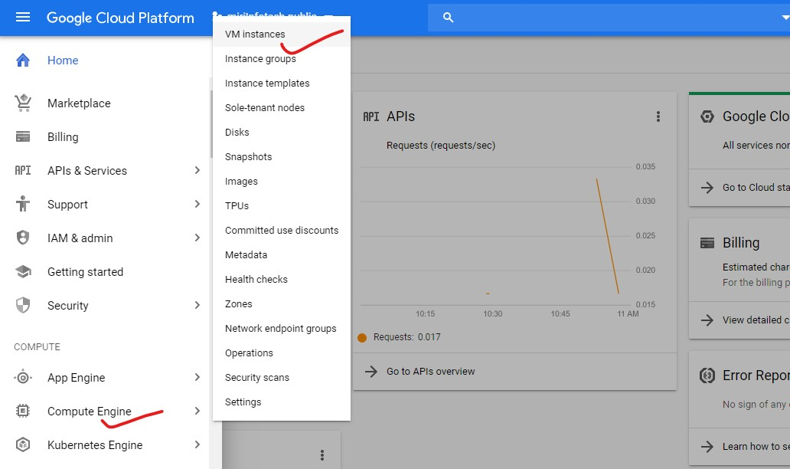

Step 2: Click on create new VM instance:
Note- Take special care of the naming conventions. It should be like: wordpress-29012020 – (name of the product followed by the present date)
Subscription- pay-as-you-go
Region- select us-east4 (Northern Virginia) us-east4-c or any other zone
Machine family will be- General-purpose
Series- N1
Machine type- g1-small, N1 standard (depending on product)
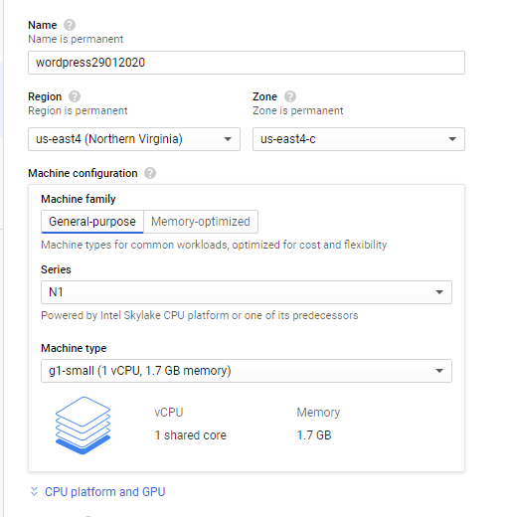
Step 3: Boot disk- change boot disk check for shielded VM feature and then go for (Ubuntu 18.04 LTS)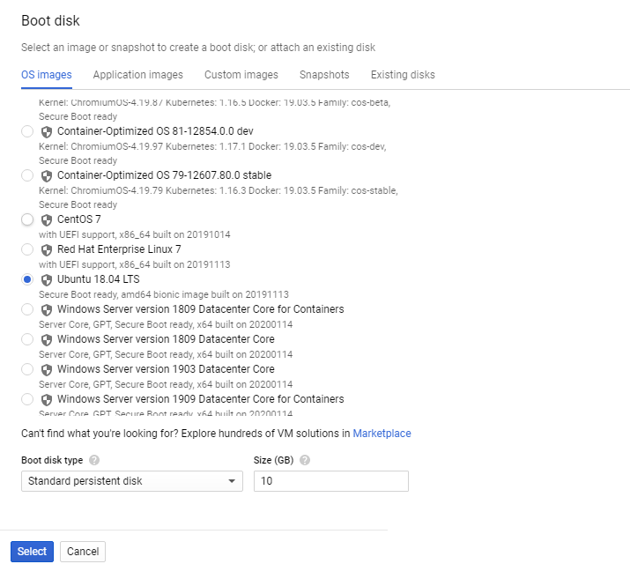
Click on select.

Step 4: Identity and API access- Allow full access to all Cloud APIs
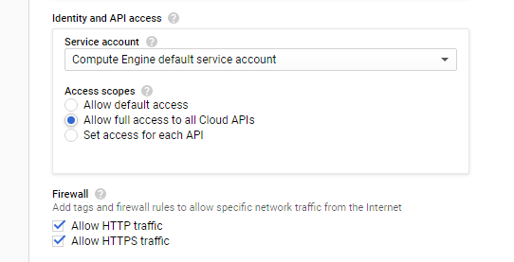
Firewall- Allow HTTP/HTTPS traffic
Step 5: Leave management as default,
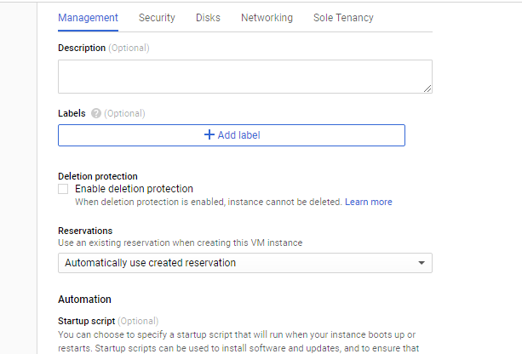

Step 6: In security tag uncheck vTPM,
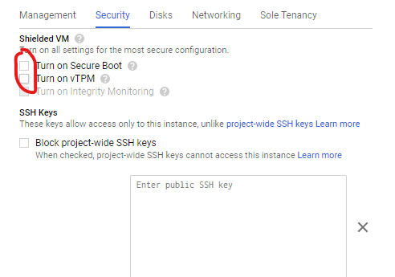

go to disk and uncheck Deletion rule (to save disk even after termination),
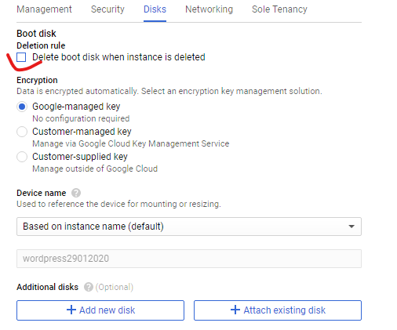
go to Networking and create a network tag as product name (WordPress),
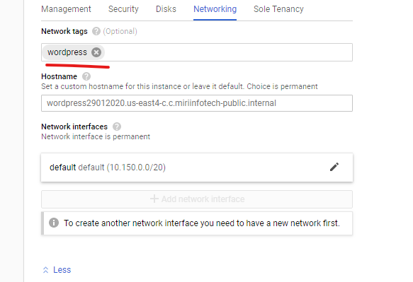

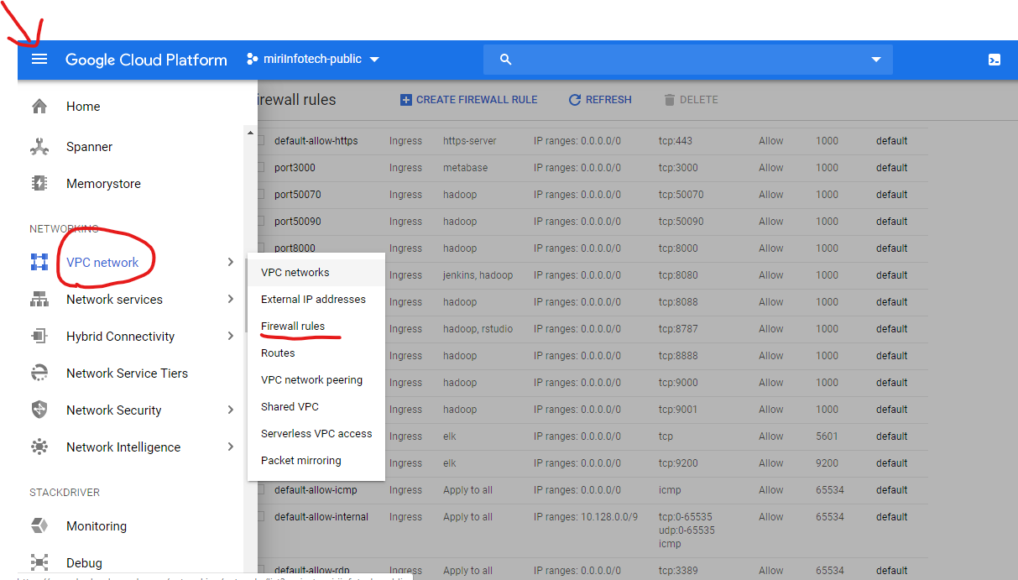

leave sole Tenancy as default, and click on create.
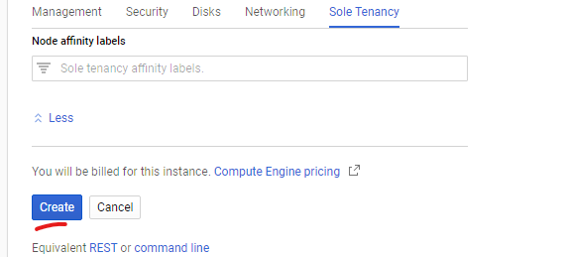
In few minutes your VM will be created:
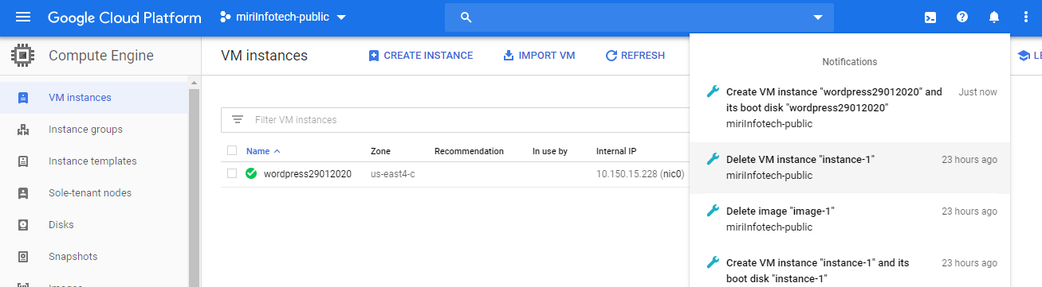

Step7: Now to work on your VM go to SSH and select open in browser window
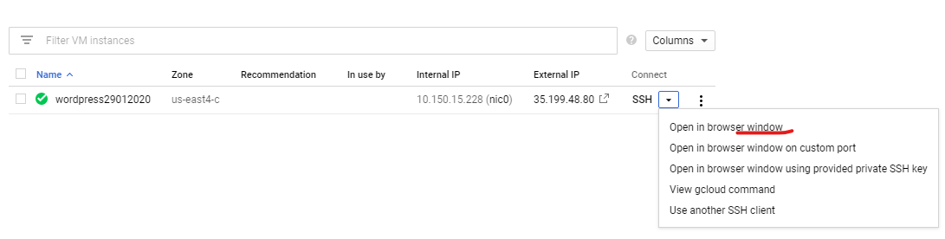
It will open a new tab with VM console i.e. similar to your putty shell: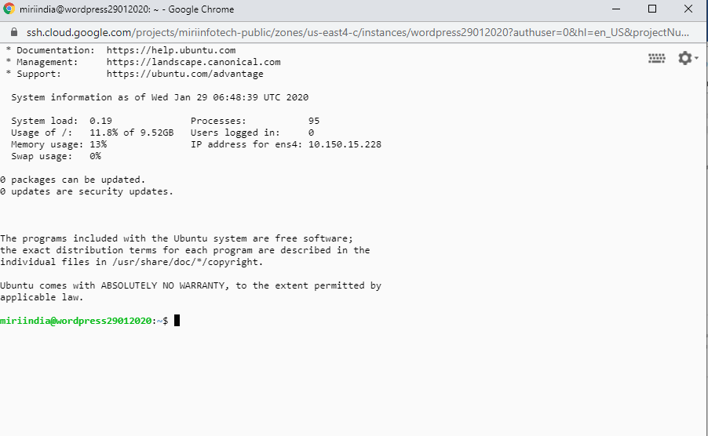
Now you can use Ubuntu commands as per your product requirement.
Step 7: Once the installation page is displayed on your instance ip.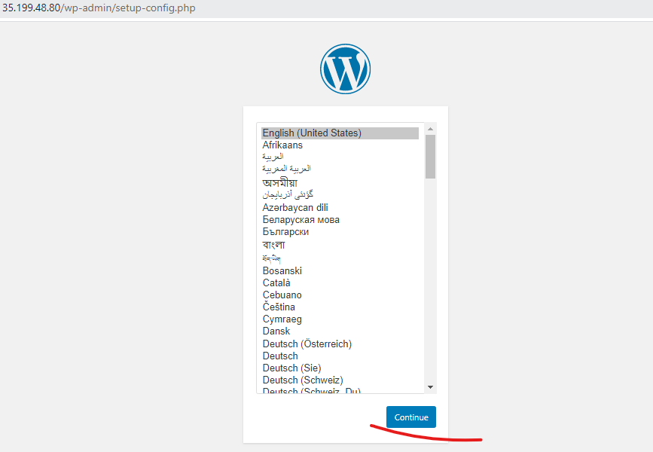
Highlight the path to your license.txt file and save the screenshot.
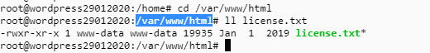
And then you can terminate your instance but do not delete your bootdisk.

Step 8: Now to create a licensed image of Virtual Machine
Download GCloud SDK
To initialize Cloud SDK:
Run: - gcloud init
Create or select a configuration if prompted.
Complete the authorization step when prompted.
Choose a current Cloud Platform project if prompted.
Choose a default Google Compute Engine zone if prompted.

Step 9: Now go to partner portal via: -
https://console.cloud.google.com/partner/solutions?project=miriinfotech-public
Then click on add solution.
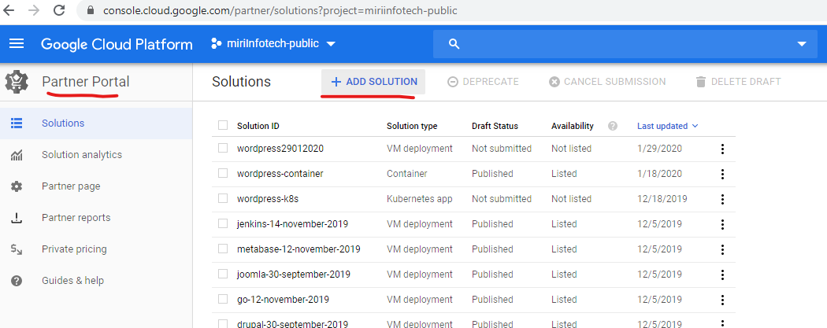
Step 10: Give solution name same as virtual machine name and click on create.
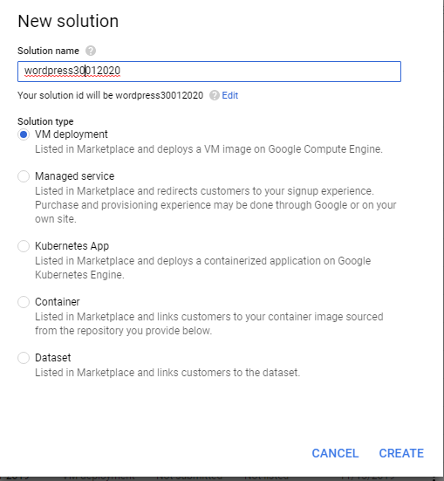
Step 11: now click on your drafted solution,
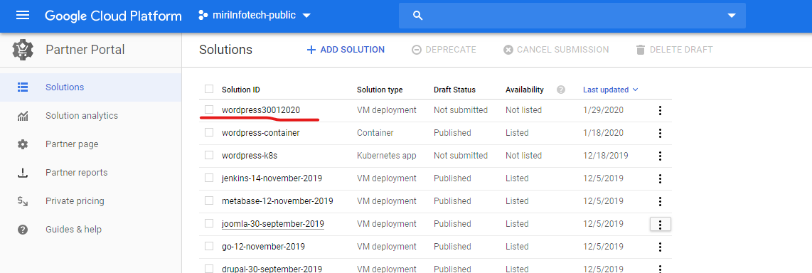
Then edit Licensing & pricing,
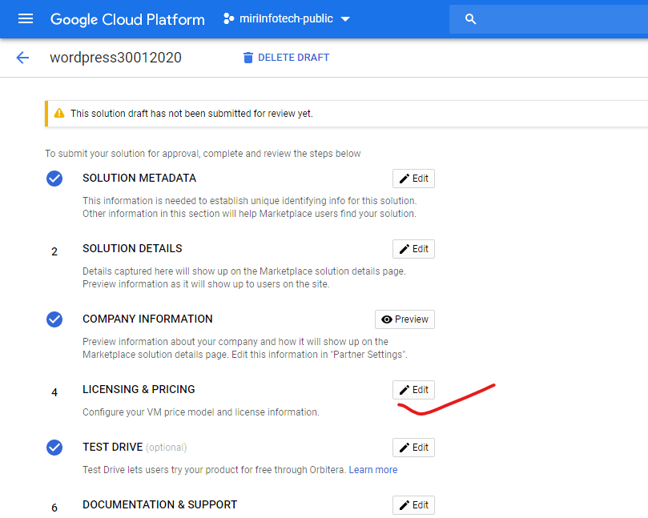
Step 12: Select pricing model according to solution and then save your license.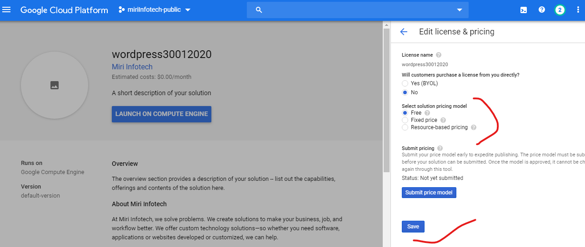
After this you can easily create a licensed image of your product by running following command in your cmd or google cloud sdk.
gcloud compute images create CREATE_IMAGE_NAME \
--project PUBLIC_PROJECT_NAME \
--source-disk projects/DEV_PROJECT_NAME/zones/SOURCE_DISK_ZONE/disks/SOURCE_DISK_NAME \
--licenses projects/PUBLIC_PROJECT_NAME/global/licenses/LICENSE_NAME \
--description ADD_DESCRIPTION

for this WordPress we used,
gcloud compute images create miriinfotech-public-ubuntu1804lts-wordpress-29012020 --project miriinfotech-public --source-disk projects/miriinfotech-public/zones/us-east4-c/disks/wordpress29012020 --licenses projects/miriinfotech-public/global/licenses/wordpress30012020 --description wordpress

once this command is successfully run your licensed image is created which is ready for publication on marketplace.

